**Skewness**

**Skewness** is a measure of how asymmetric a distribution is compared to a normal (bell-shaped) distribution. It tells us whether the data is skewed to the left or right.

### **Types of Skewness**

1. **Zero Skewness (Symmetrical Distribution)**
   * The left and right sides of the distribution are roughly equal.
   * Example: Heights of people in a population.
2. **Positive Skewness (Right-Skewed)**
   * The right tail (higher values) is longer.
   * More data is concentrated on the left.
   * Example: Income distribution (a few people earn very high salaries, shifting the tail to the right).
3. **Negative Skewness (Left-Skewed)**
   * The left tail (lower values) is longer.
   * More data is concentrated on the right.
   * Example: Exam scores (if most students score high, but a few score very low).

### **Formula for Skewness**

The formula for **Pearson’s skewness** is:

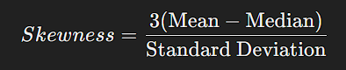

* **If Skewness > 0**, it is **positively skewed**.
* **If Skewness < 0**, it is **negatively skewed**.
* **If Skewness = 0**, it is **symmetrical**.